

Base image

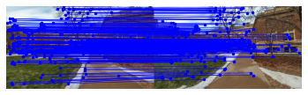Visualization of bi-directional matching. After loading the images, SIFT feature matching was done using a NN-ratio test of 0.7 and a bi-directional check filter.

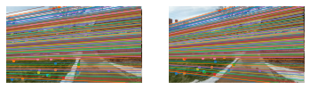

Visualization of epipolar lines. SIFT correspondences in left and right images were represented with epipolar lines. Computed using fundamental matrix, which is a combination of RANSAC and 8-point algorithm. 1000 RANSAC iterations were used. SVD clean-up was applied.

Visualization of triangulation and camera pose. Linear triangulation method, final disambiguated camera pose, done by checking points in front of camera.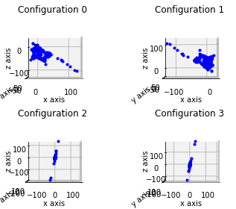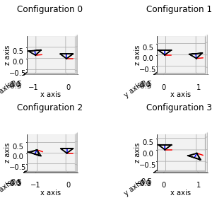

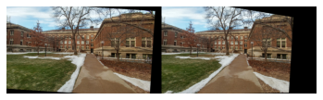

Visualization of Stereo rectification

Done by calculating homographs

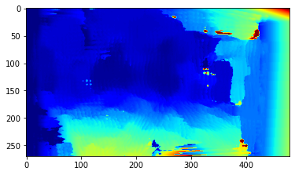

Visualization of stereo match.